Data Navigator overview

Introduction
The DataNavigator™ (DN) system is a modular, flexible EFT product created by eFundsSM. It can be used in a variety of ways to meet your specific business needs related to the settlement process as well as transaction research.

DataNavigator is divided into two primary components: the DataNavigator Client and the DataNavigator Server. The DataNavigator Client supports the GUI application and the connection to the communication network that accesses the server. The DataNavigator Server supports all customers that are logged on to the system simultaneously and manages the Data Repository.

The Client GUI provides a user friendly interface that keeps the complexity of the application away from the user.

Transaction data is added to the Data Repository within minutes of transaction completion. Transaction research can be performed on a configurable amount of data. The most recent transaction data is stored on Direct Access Storage Devices (DASD) which allows for fast retrieval. Older data can be archived and accessed from tape storage as needed

A key to system performance is the scalability of the DataNavigator™ software. It can easily be expanded to accommodate growth in transaction volume.

All transaction processing is performed when the transaction data is added to the Data Repository. Totals are accumulated immediately and remain on the repository as long as the user would like to maintain these totals. User inquiries can access totals that are currently being accumulated for today’s activity or from a prior day’s historical totals. The accumulation process automatically switches over to the next business day when all transactions for the current day have been processed.

The Transaction Research Engine provides a simple and easy way to look up transaction information. Once a transaction that requires an exception is identified, the information on the Data Repository can be used to automatically create an adjustment entry. The user only needs to enter a minimum amount of information (such as why the adjustment was necessary) in order to process the exception item

DataNavigator product
DataNavigator™ provides excellent processing capabilities because it incorporates the latest in technology and is structured for high performance.
- Latest technology concepts
- High performance

System design
The foundation DataNavigator™ product contains all of the programs that support the system. These programs are illustrated in the following diagram.

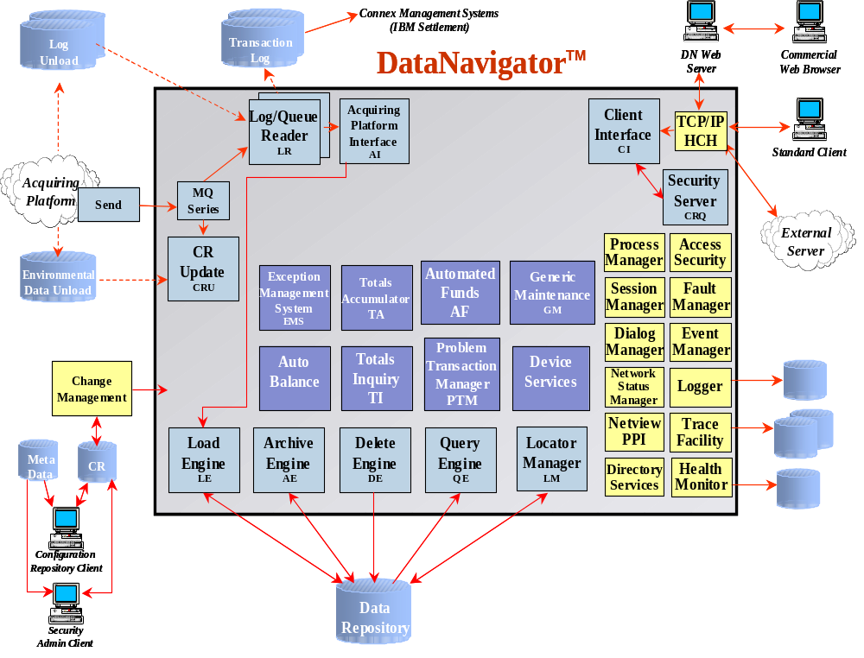

The DataNavigator system can be broken out into distinct components. Each of these components will be reviewed in detail within this section.
- Configuration repository
- Connex™ foundation services
- Acquiring platform
- Log processing
- Repository loading and maintenance
- Client interfaces
- Client processing
- Exception Management System (EMS)

Configuration Repository
The Configuration Repository (CR) is the storage location for all of the parameters used by the system.

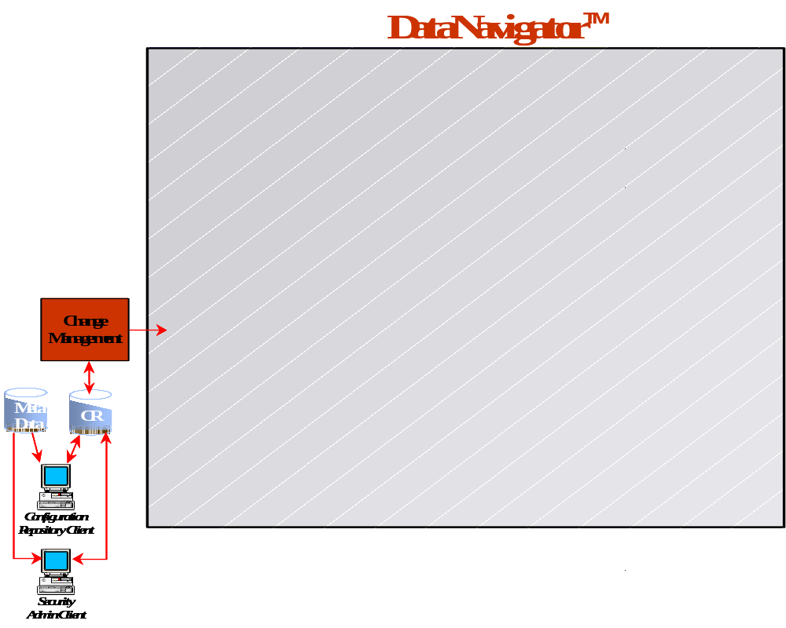

Configuration parameters are entered into the system through two different methods. The first method is for the user to enter changes into the database from the Acquiring Platform. After processing the changes through the change control mechanism of the Acquiring Platform, the changes are passed to the DataNavigator™ server. Then the changes are reformatted into a DataNavigator standard format and an update is performed to the DataNavigator Configuration Repository.

The second method allows the user to enter changes directly into the DataNavigator Configuration Repository. These changes are bundled into a change group, and are processed through a change control mechanism unique to the DataNavigator platform.

After the change groups are completed and prepared to rollin, new extract files are created from the DataNavigator Configuration Repository. Then a message is sent to any process in the DataNavigator server that may use the new information within the particular extract files. Lastly, the affected processes suspend processing momentarily to refresh the information that is used from the extract files. After refreshing the files, the changes become part of the productive environment.

Connex Foundation Services
Connex™ Foundation Services are components of the Connex™ on IBM® Application. These components perform the same functions for DataNavigator™ as they do for the online switch.

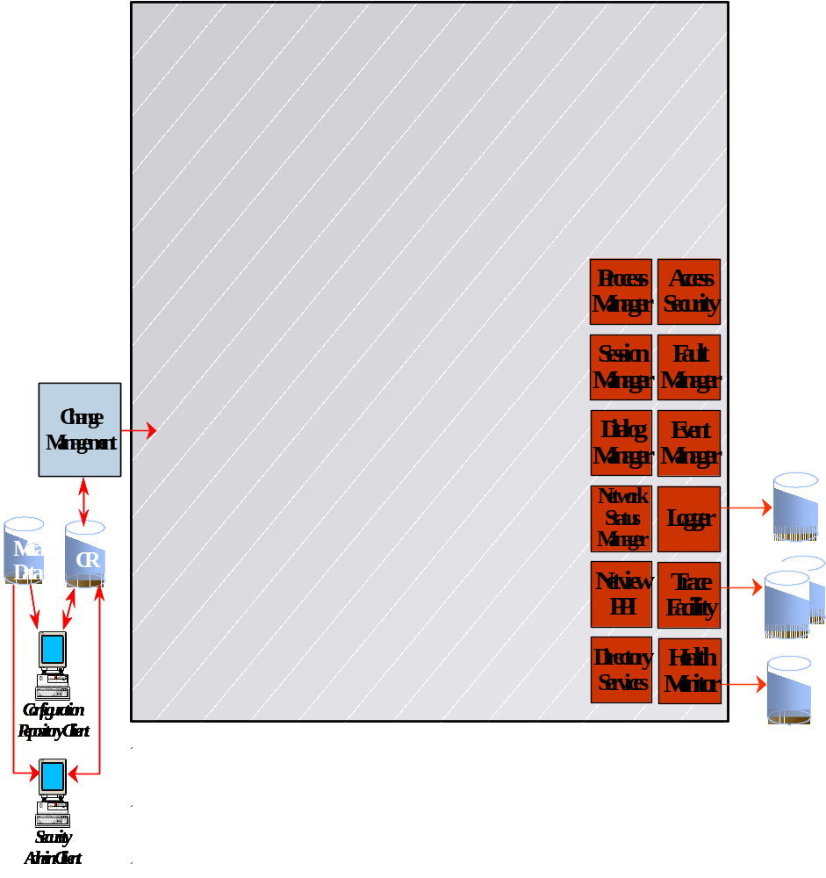

UCH Con and Dialog Manager provide a Connex Console that provides a window to look at the performance of DataNavigator and monitor or respond to messages produced by any task in the system. Access Security approves logon IDs for both console operators and client users. Certain events, such as end-of-day processing occur on a regular calendar day basis. Event Manager sends messages to trigger the start of an event. Event Manager works on a schedule established for those tasks that need to be reminded of the start of an event. Logger is responsible for writing key information to disk. Key information is determined by the individual tasks in DataNavigator. Network Status Monitor keeps track of the components that make up DataNavigator. Netview PPI is a vehicle for receiving messages from outside of the DataNavigator environment. Trace Facility is a utility that records and reports on activities of individual tasks that are being analyzed for performance or problem resolution. Finally, Health Monitor summarizes activities of certain tasks and/or types of messages and takes action based on user defined triggers.

